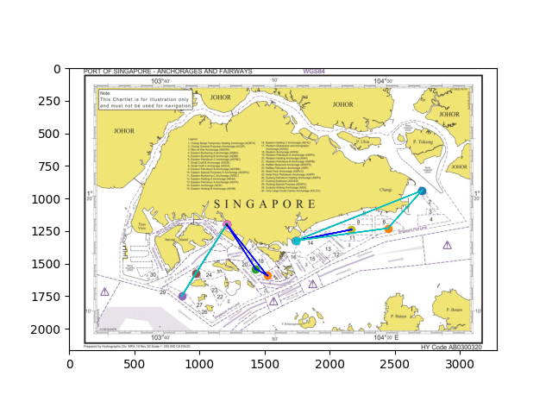LT1

Launch 1: West Coast Pier -> Zone 21 -> Zone 17 -> West Coast Pier

Launch 2: West Coast Pier -> Zone 28 -> Zone 25 -> West Coast Pier

Launch 3: Marina South Pier -> Zone 10 -> Marina South Pier

Launch 4: Marina South Pier -> Zone 5 -> Zone 1 -> Marina South Pier

Launch 5 (Unused)

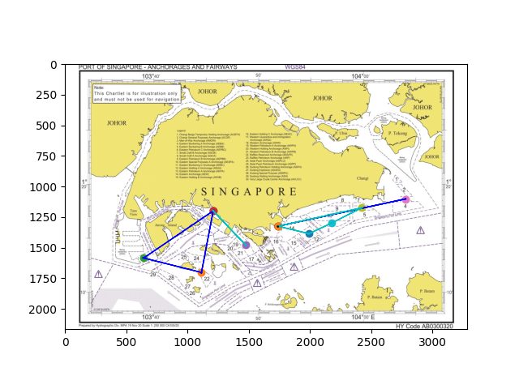LT2

Launch 1: West Coast Pier -> Zone 18 -> West Coast Pier

Launch 2: West Coast Pier -> Zone 23 -> Zone 30 -> West Coast Pier

Launch 3: Marina South Pier -> Zone 10 -> Marina South Pier

Launch 4: Marina South Pier -> Zone 6 -> Zone 11 -> Zone 13 -> Marina South Pier

Launch 5 (Unused)

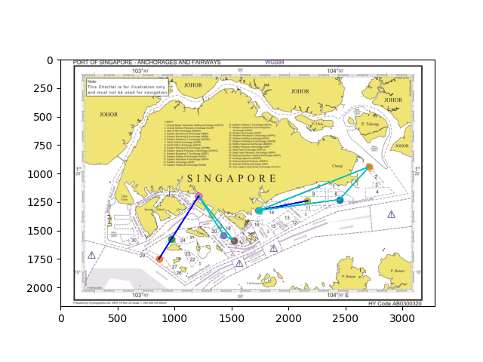LL1

Launch 1: West Coast Pier -> Zone 17 -> Zone 21 -> West Coast Pier

Launch 2: West Coast Pier -> Zone 28 -> Zone 25 -> West Coast Pier

Launch 3: Marina South Pier -> Zone 10 -> Marina South Pier

Launch 4: Marina South Pier -> Zone 5 -> Zone 1 -> Marina South Pier

Launch 5 (Unused)

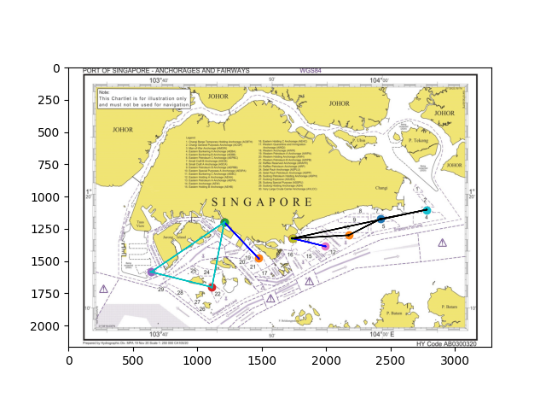LL2

Launch 1: West Coast Pier -> Zone 18 -> West Coast Pier

Launch 2: West Coast Pier -> Zone 23 -> Zone 30 -> West Coast Pier

Launch 3: Marina South Pier -> Zone 13 -> Marina South Pier

Launch 4: Marina South Pier -> Zone 3 -> Zone 6 -> Zone 11 -> Marina South Pier

Launch 5 (Unused)

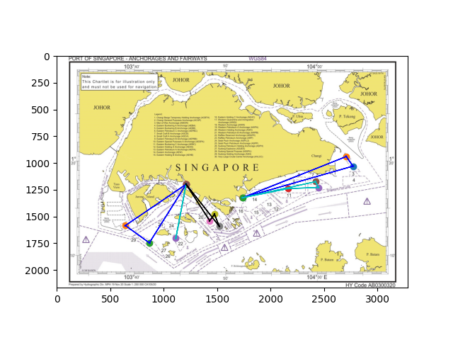MT1

Launch 1: West Coast Pier -> Zone 23 -> West Coast Pier

Launch 2: West Coast Pier -> Zone 30 -> Zone 28 -> West Coast Pier

Launch 3: West Coast Pier -> Zone 17 -> Zone 18 -> Zone 21 -> West Coast Pier

Launch 4: Marina South Pier -> Zone 2 -> Zone 1 -> Marina South Pier

Launch 5: Marina South Pier -> Zone 10 -> Zone 5 -> Zone 6 -> Marina South Pier

MT2

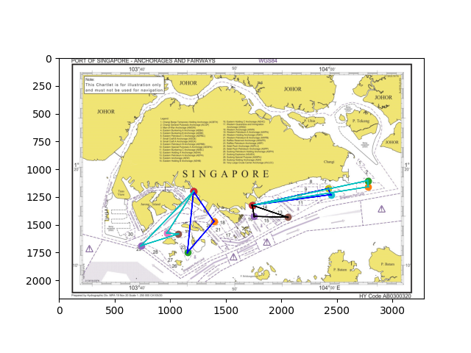Launch 1: West Coast Pier -> Zone 22 -> Zone 19 -> West Coast Pier

Launch 2: West Coast Pier -> Zone 29 -> Zone 24 -> Zone 25 -> West Coast Pier

Launch 3: Marina South Pier -> Zone 6 -> Zone 5 -> Marina South Pier

Launch 4: Marina South Pier -> Zone 4 -> Zone 3 -> Marina South Pier

Launch 5: Marina South Pier -> Zone 16 -> Zone 12 -> Marina South Pier

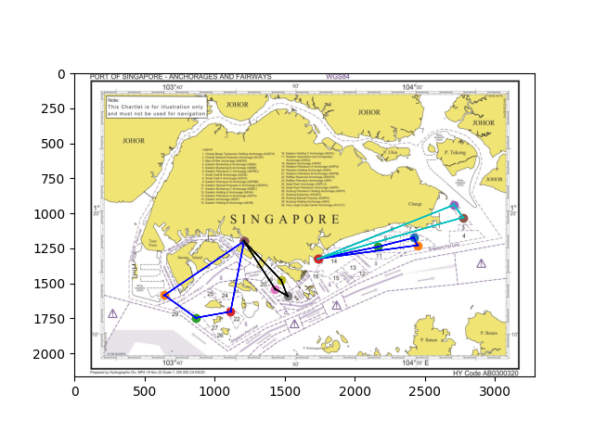ML1

Launch 1: West Coast Pier -> Zone 21 -> Zone 17 -> Zone 18 -> West Coast Pier

Launch 2: West Coast Pier -> Zone 30 -> Zone 28 -> Zone 23 -> West Coast Pier

Launch 3: Marina South Pier -> Zone 2 -> Zone 1 -> Marina South Pier

Launch 4: Marina South Pier -> Zone 5 -> Zone 6 -> Zone 10 -> Marina South Pier

Launch 5 (Unused)

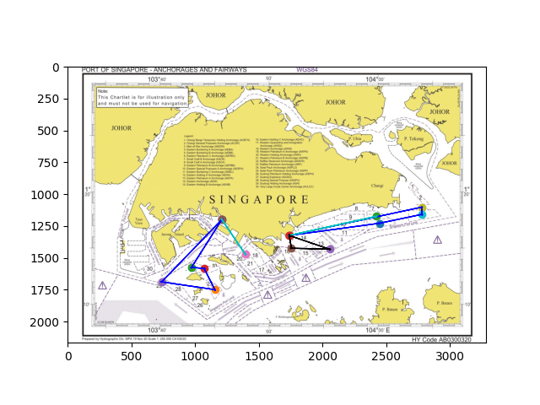ML2

Launch 1: West Coast Pier -> Zone 19 -> West Coast Pier

Launch 2: West Coast Pier -> Zone 24 -> Zone 25 -> Zone 22 -> Zone 29 -> West Coast Pier

Launch 3: Marina South Pier -> Zone 6 -> Marina South Pier

Launch 4: Marina South Pier -> Zone 3 -> Zone 4 -> Zone 5 -> Marina South Pier

Launch 5: Marina South Pier -> Zone 12 -> Zone 16 -> Marina South Pier

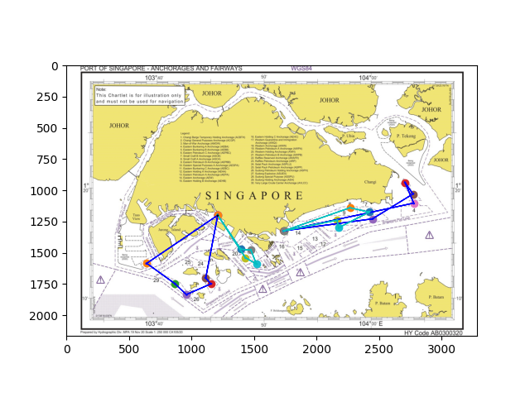HT1

Launch 1: West Coast Pier -> Zone 21 -> Zone 17 -> Zone 18 -> Zone 19 -> West Coast Pier

Launch 2: West Coast Pier -> Zone 30 -> Zone 28 -> Zone 27 -> Zone 22 -> Zone 23 -> West Coast Pier

Launch 3: Marina South Pier -> Zone 10 -> Zone 11 -> Zone 6 -> Zone 8 -> Marina South Pier

Launch 4: Marina South Pier -> Zone 5 -> Zone 2 -> Zone 1 -> Zone 3 -> Marina South Pier

Launch 5 (Unused)

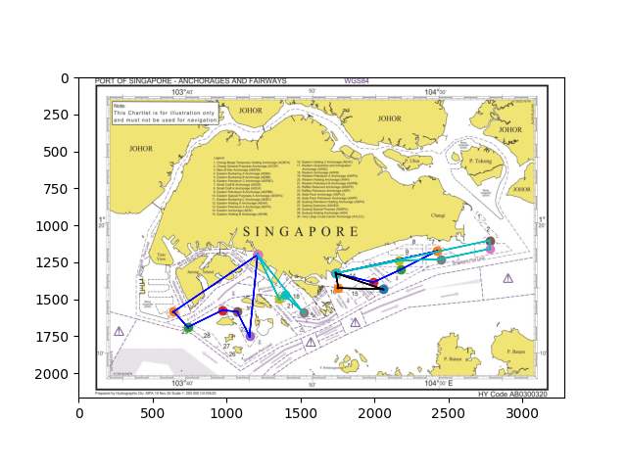HT2

Launch 1: West Coast Pier -> Zone 30 -> Zone 29 -> Zone 25 -> Zone 24 -> Zone 22 -> West Coast Pier

Launch 2: West Coast Pier -> Zone 20 -> Zone 19 -> Zone 17 -> West Coast Pier

Launch 3: Marina South Pier -> Zone 12 -> Zone 16 -> Marina South Pier

Launch 4: Marina South Pier -> Zone 6 -> Zone 11 -> Zone 13 -> Marina South Pier

Launch 5: Marina South Pier -> Zone 3 -> Zone 4 -> Zone 5 -> Zone 10 -> Marina South Pier

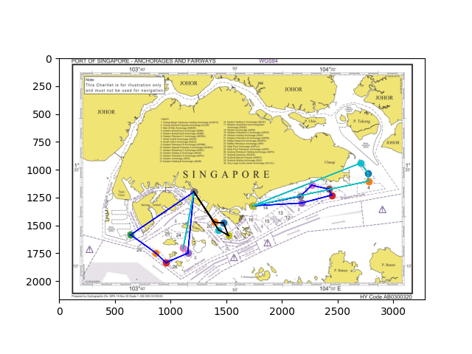HL1

Launch 1: West Coast Pier -> Zone 23 -> West Coast Pier

Launch 2: West Coast Pier -> Zone 30 -> Zone 28 -> Zone 27 -> Zone 22 -> West Coast Pier

Launch 3: West Coast Pier -> Zone 21 -> Zone 17 -> Zone 18 -> Zone 19 -> West Coast Pier

Launch 4: Marina South Pier -> Zone 1 -> Zone 2 -> Zone 3 -> Marina South Pier

Launch 5: Marina South Pier -> Zone 11 -> Zone 5 -> Zone 6 -> Zone 8 -> Zone 10 -> Marina South Pier

HL2

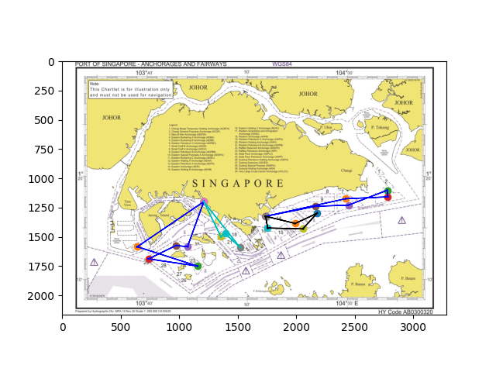Launch 1: West Coast Pier -> Zone 20 -> Zone 19 -> Zone 17 -> West Coast Pier

Launch 2: West Coast Pier -> Zone 30 -> Zone 22 -> Zone 29 -> Zone 25 -> Zone 24 -> West Coast Pier

Launch 3: Marina South Pier -> Zone 16 -> Zone 12 -> Zone 11 -> Zone 13 -> Marina South Pier

Launch 4: Marina South Pier -> Zone 6 -> Zone 4 -> Zone 3 -> Zone 5 -> Zone 10 -> Marina South Pier

Launch 5 (Unused)

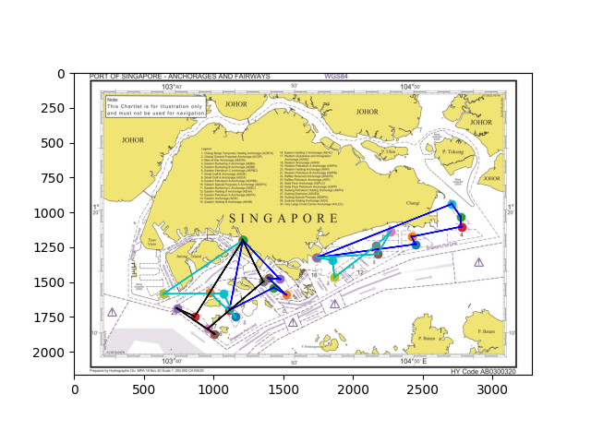ET1

Launch 1: West Coast Pier -> Zone 23 -> Zone 21 -> Zone 17 -> Zone 19 -> Zone 18 -> West Coast Pier

Launch 2: West Coast Pier -> Zone 30 -> Zone 30 -> Zone 24 -> Zone 22 -> Zone 25 -> West Coast Pier

Launch 3: West Coast Pier -> Zone 28 -> Zone 22 -> Zone 26 -> Zone 27 -> Zone 20 -> West Coast Pier

Launch 4: Marina South Pier -> Zone 5 -> Zone 6 -> Zone 3 -> Zone 2 -> Zone 1 -> Marina South Pier

Launch 5: Marina South Pier -> Zone 11 -> Zone 8 -> Zone 10 -> Zone 15 -> Zone 14 -> Marina South Pier

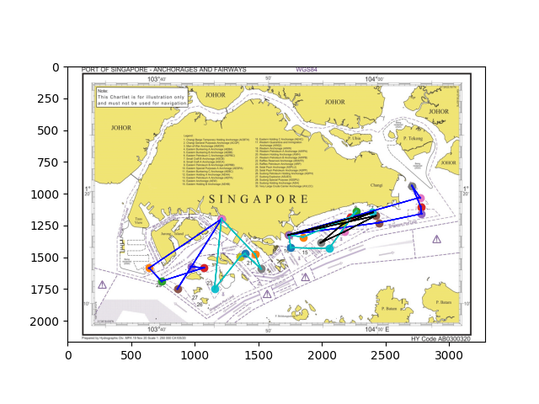ET2

Launch 1: West Coast Pier -> Zone 30 -> Zone 29 -> Zone 24 -> Zone 25 -> Zone 28 -> West Coast Pier

Launch 2: West Coast Pier -> Zone 22 -> Zone 20 -> Zone 19 -> Zone 17 -> Zone 18 -> West Coast Pier

Launch 3: Marina South Pier -> Zone 5 -> Zone 4 -> Zone 3 -> Zone 1 -> Zone 7 -> Marina South Pier

Launch 4: Marina South Pier -> Zone 16 -> Zone 12 -> Zone 8 -> Zone 9 -> Zone 14 -> Marina South Pier

Launch 5: Marina South Pier -> Zone 6 -> Zone 11 -> Zone 13 -> Zone 10 -> Zone 7 -> Marina South Pier

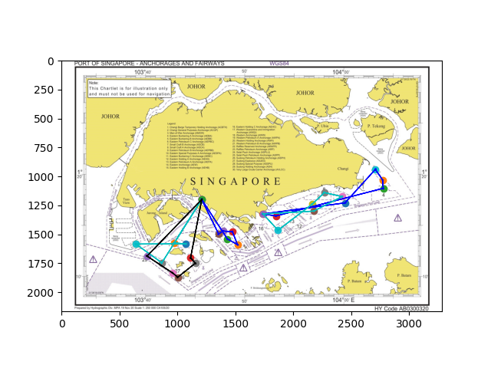EL1

Launch 1: West Coast Pier -> Zone 21 -> Zone 17 -> Zone 18 -> Zone 19 -> Zone 20 -> West Coast Pier

Launch 2: West Coast Pier -> Zone 28 -> Zone 30 -> Zone 30 -> Zone 24 -> Zone 25 -> West Coast Pier

Launch 3: West Coast Pier -> Zone 23 -> Zone 22 -> Zone 26 -> Zone 27 -> Zone 29 -> West Coast Pier

Launch 4: Marina South Pier -> Zone 5 -> Zone 1 -> Zone 2 -> Zone 3 -> Zone 14 -> Marina South Pier

Launch 5: Marina South Pier -> Zone 11 -> Zone 6 -> Zone 8 -> Zone 10 -> Zone 15 -> Marina South Pier

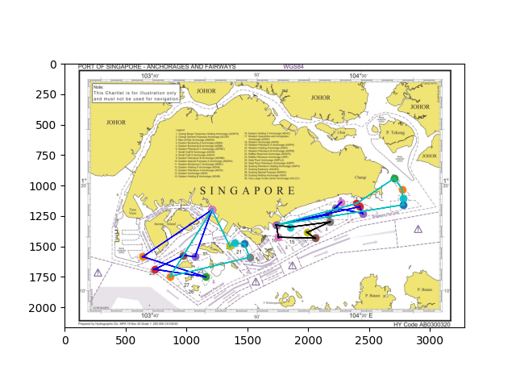EL2

Launch 1: West Coast Pier -> Zone 30 -> Zone 22 -> Zone 29 -> Zone 25 -> Zone 24 -> West Coast Pier

Launch 2: West Coast Pier -> Zone 20 -> Zone 19 -> Zone 18 -> Zone 17 -> Zone 28 -> West Coast Pier

Launch 3: Marina South Pier -> Zone 6 -> Zone 5 -> Zone 9 -> Zone 8 -> Zone 10 -> Marina South Pier

Launch 4: Marina South Pier -> Zone 4 -> Zone 3 -> Zone 2 -> Zone 1 -> Zone 7 -> Marina South Pier

Launch 5: Marina South Pier -> Zone 16 -> Zone 12 -> Zone 13 -> Zone 11 -> Zone 14 -> Marina South Pier

C1

Launch 1: West Coast Pier -> Zone 28 -> Zone 29 -> Zone 30 -> West Coast Pier

Launch 2: West Coast Pier -> Zone 20 -> Zone 19 -> West Coast Pier

Launch 5: Marina South Pier -> Zone 15 -> Zone 16 -> Marina South Pier

Launch 4: Marina South Pier -> Zone 3 -> Zone 2 -> Zone 1 -> Marina South Pier

Launch 5 (Unused)

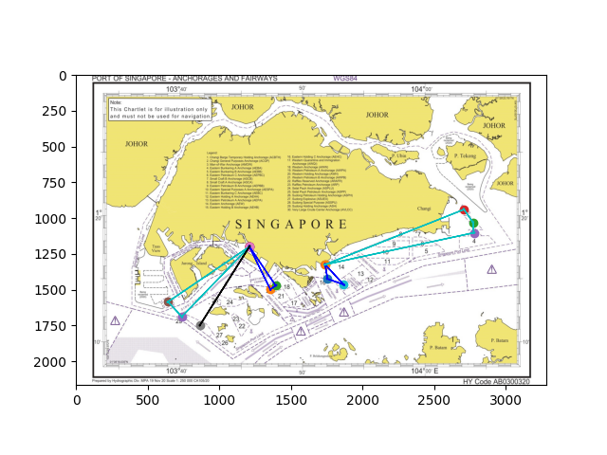C2

Launch 1: West Coast Pier -> Zone 28 -> West Coast Pier

Launch 2: West Coast Pier -> Zone 30 -> Zone 29 -> West Coast Pier

Launch 3: West Coast Pier -> Zone 20 -> Zone 19 -> West Coast Pier

Launch 4: Marina South Pier -> Zone 15 -> Zone 16 -> Marina South Pier

Launch 5: Marina South Pier -> Zone 3 -> Zone 2 -> Zone 1 -> Marina South Pier

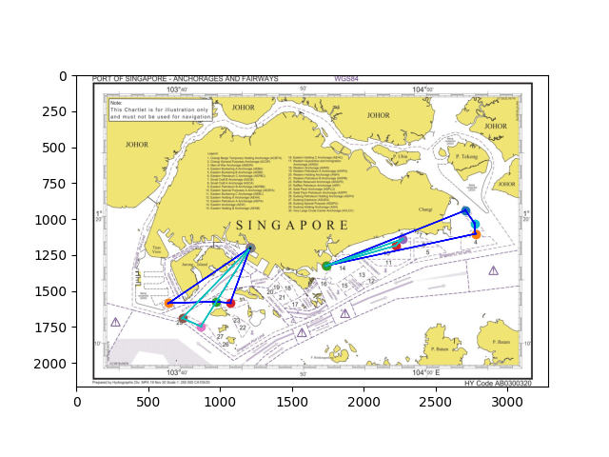C3

Launch 1: West Coast Pier -> Zone 29 -> Zone 28 -> West Coast Pier

Launch 2: West Coast Pier -> Zone 30 -> Zone 24 -> Zone 25 -> West Coast Pier

Launch 3: Marina South Pier -> Zone 8 -> Zone 9 -> Marina South Pier

Launch 4: Marina South Pier -> Zone 3 -> Zone 2 -> Zone 1 -> Marina South Pier

Launch 5 (Unused)

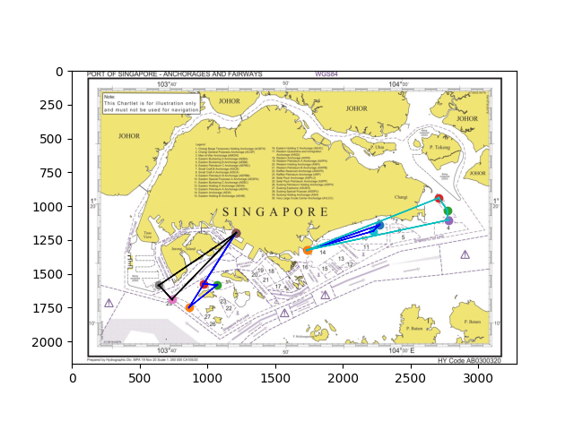C4

Launch 1: West Coast Pier -> Zone 29 -> Zone 30 -> West Coast Pier

Launch 2: West Coast Pier -> Zone 28 -> Zone 24 -> Zone 25 -> West Coast Pier

Launch 3: Marina South Pier -> Zone 8 -> Zone 9 -> Marina South Pier

Launch 4: Marina South Pier -> Zone 3 -> Zone 2 -> Zone 1 -> Marina South Pier

Launch 5 (Unused)

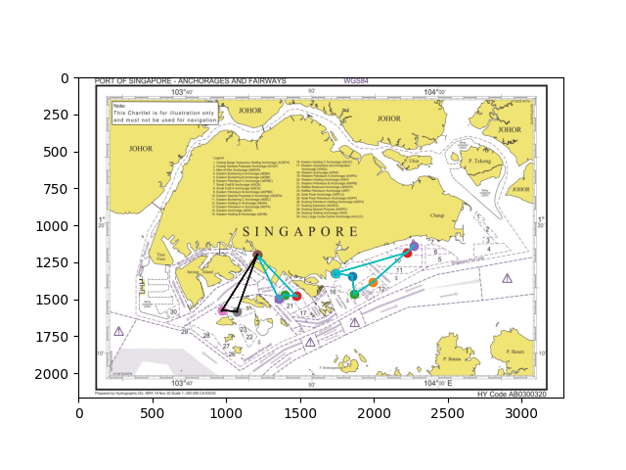C5

Launch 1: West Coast Pier -> Zone 25 -> Zone 24 -> West Coast Pier

Launch 2: West Coast Pier -> Zone 20 -> Zone 19 -> Zone 18 -> West Coast Pier

Launch 3: Marina South Pier -> Zone 14 -> Zone 15 -> Zone 13 -> Zone 8 -> Zone 9 -> Marina South Pier

Launch 4 (Unused)

Launch 5 (Unused)

C6

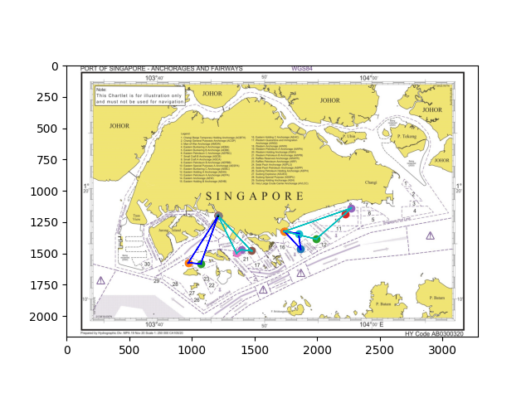Launch 1: West Coast Pier -> Zone 25 -> Zone 24 -> West Coast Pier

Launch 2: West Coast Pier -> Zone 20 -> Zone 19 -> Zone 18 -> West Coast Pier

Launch 3: Marina South Pier -> Zone 14 -> Zone 15 -> Marina South Pier

Launch 4: Marina South Pier -> Zone 13 -> Zone 9 -> Zone 8 -> Marina South Pier

Launch 5 (Unused)

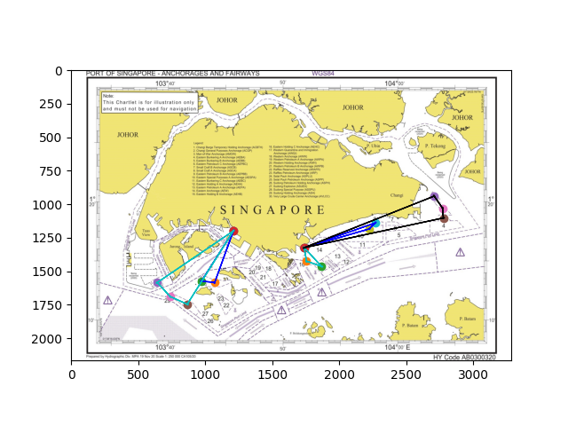C7

Launch 1: West Coast Pier -> Zone 24 -> Zone 25 -> West Coast Pier

Launch 2: West Coast Pier -> Zone 30 -> Zone 29 -> Zone 28 -> West Coast Pier

Launch 3: Marina South Pier -> Zone 16 -> Zone 15 -> Marina South Pier

Launch 4: Marina South Pier -> Zone 9 -> Zone 8 -> Marina South Pier

Launch 5: Marina South Pier -> Zone 3 -> Zone 2 -> Zone 1 -> Marina South Pier

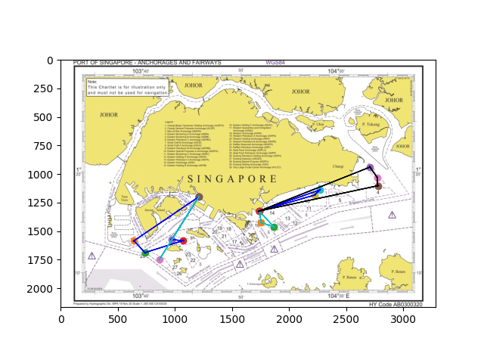C8

Launch 1: West Coast Pier -> Zone 28 -> West Coast Pier

Launch 2: West Coast Pier -> Zone 30 -> Zone 29 -> Zone 24 -> Zone 25 -> West Coast Pier

Launch 3: Marina South Pier -> Zone 16 -> Zone 15 -> Marina South Pier

Launch 4: Marina South Pier -> Zone 9 -> Zone 8 -> Marina South Pier

Launch 5: Marina South Pier -> Zone 3 -> Zone 2 -> Zone 1 -> Marina South Pier

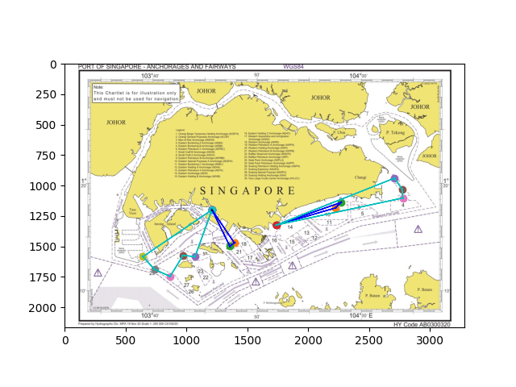C9

Launch 1: West Coast Pier -> Zone 20 -> Zone 19 -> West Coast Pier

Launch 2: West Coast Pier -> Zone 24 -> Zone 25 -> Zone 28 -> Zone 29 -> Zone 30 -> West Coast Pier

Launch 3: Marina South Pier -> Zone 9 -> Zone 8 -> Marina South Pier

Launch 4: Marina South Pier -> Zone 3 -> Zone 2 -> Zone 1 -> Marina South Pier

Launch 5 (Unused)

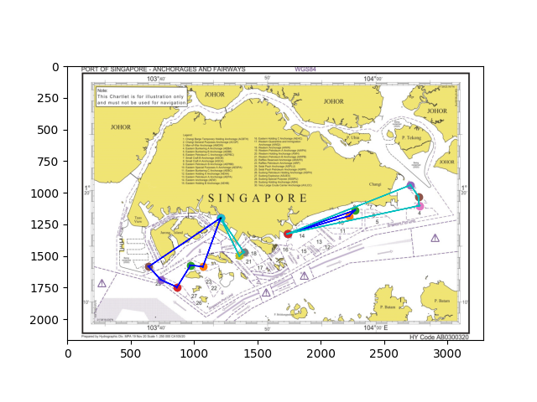C10

Launch 1: West Coast Pier -> Zone 20 -> Zone 19 -> West Coast Pier

Launch 2: West Coast Pier -> Zone 24 -> Zone 25 -> Zone 28 -> Zone 29 -> Zone 30 -> West Coast Pier

Launch 3: Marina South Pier -> Zone 9 -> Zone 8 -> Marina South Pier

Launch 4: Marina South Pier -> Zone 3 -> Zone 2 -> Zone 1 -> Marina South Pier

Launch 5 (Unused)

C11

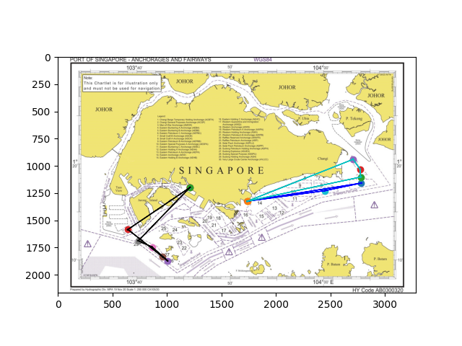Launch 1: West Coast Pier -> Zone 30 -> Zone 27 -> Zone 26 -> Zone 28 -> Zone 29 -> West Coast Pier

Launch 2: Marina South Pier -> Zone 5 -> Zone 4 -> Marina South Pier

Launch 3: Marina South Pier -> Zone 3 -> Zone 2 -> Zone 1 -> Marina South Pier

Launch 4 (Unused)

Launch 5 (Unused)

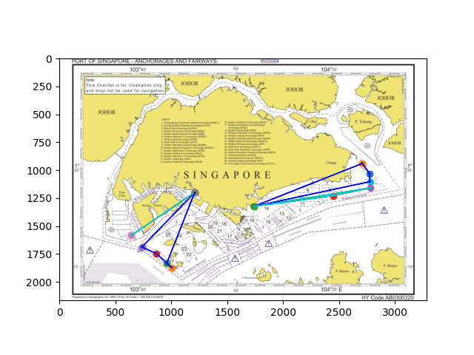C12

Launch 1: West Coast Pier -> Zone 30 -> West Coast Pier

Launch 2: West Coast Pier -> Zone 27 -> Zone 26 -> Zone 28 -> Zone 29 -> West Coast Pier

Launch 3: Marina South Pier -> Zone 5 -> Zone 4 -> Marina South Pier

Launch 4: Marina South Pier -> Zone 3 -> Zone 2 -> Zone 1 -> Marina South Pier

Launch 5 (Unused)

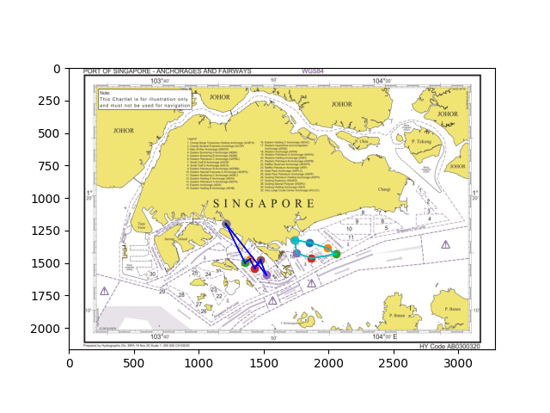C13

Launch 1: West Coast Pier -> Zone 20 -> Zone 19 -> Zone 21 -> Zone 18 -> Zone 17 -> West Coast Pier

Launch 2: Marina South Pier -> Zone 14 -> Zone 13 -> Zone 12 -> Zone 15 -> Zone 16 -> Marina South Pier

Launch 3 (Unused)

Launch 4 (Unused)

Launch 5 (Unused)

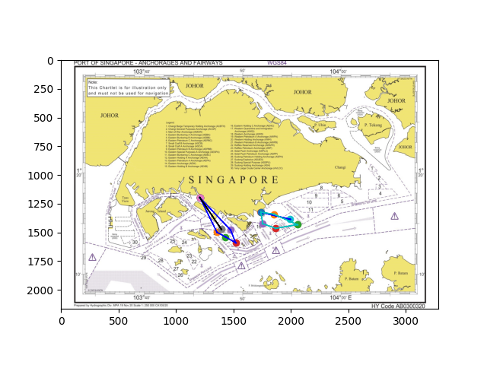C14

Launch 1: West Coast Pier -> Zone 19 -> West Coast Pier

Launch 2: West Coast Pier -> Zone 20 -> Zone 21 -> Zone 17 -> Zone 18 -> West Coast Pier

Launch 3: Marina South Pier -> Zone 13 -> Marina South Pier

Launch 4: Marina South Pier -> Zone 14 -> Zone 12 -> Zone 15 -> Zone 16 -> Marina South Pier

Launch 5 (Unused)